**Loading the dataset into R Studio**

###Loading the data #####

library(readxl)

comcat <- read.csv('C:/Users/476756/Downloads/Comcast_Telecom_Complaints_data.csv')

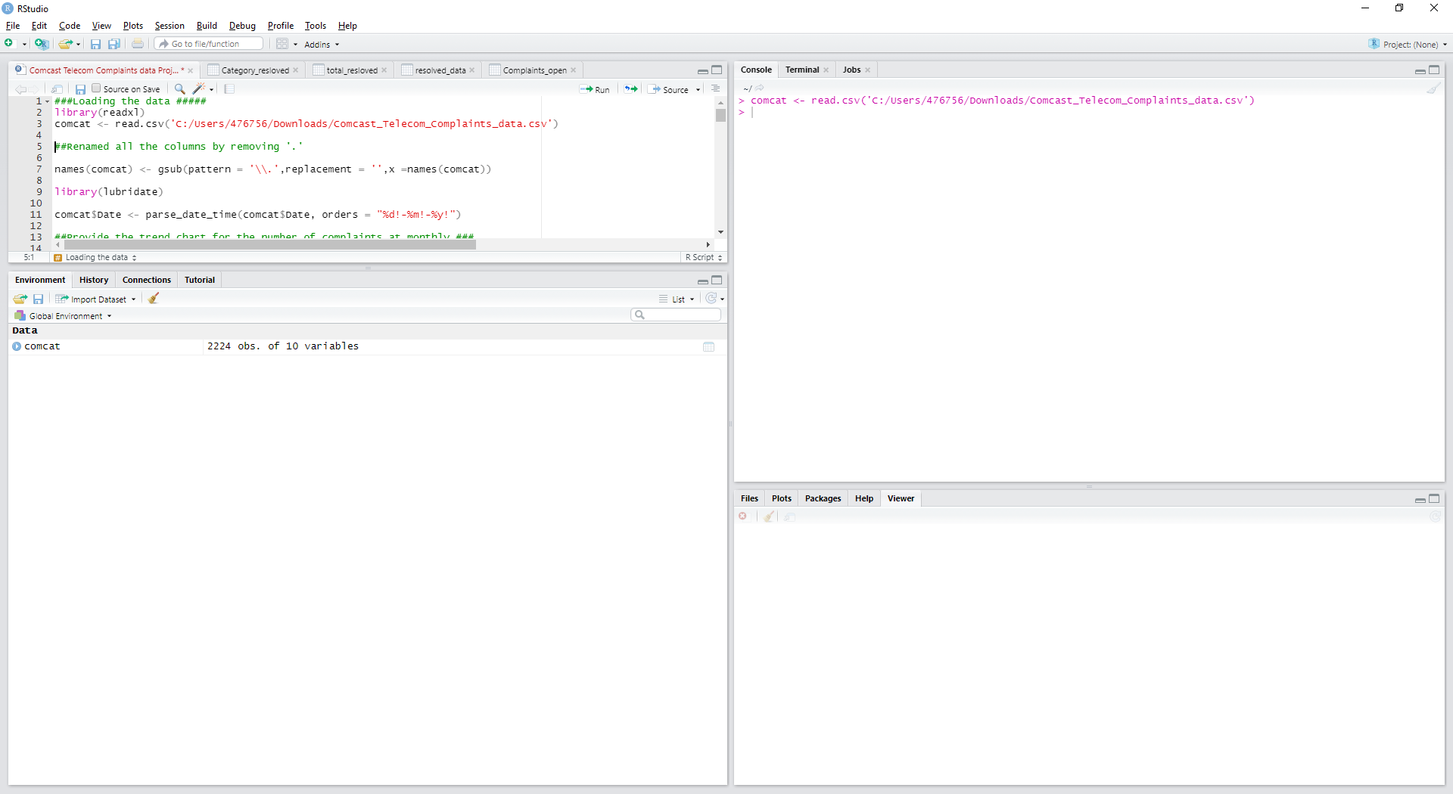

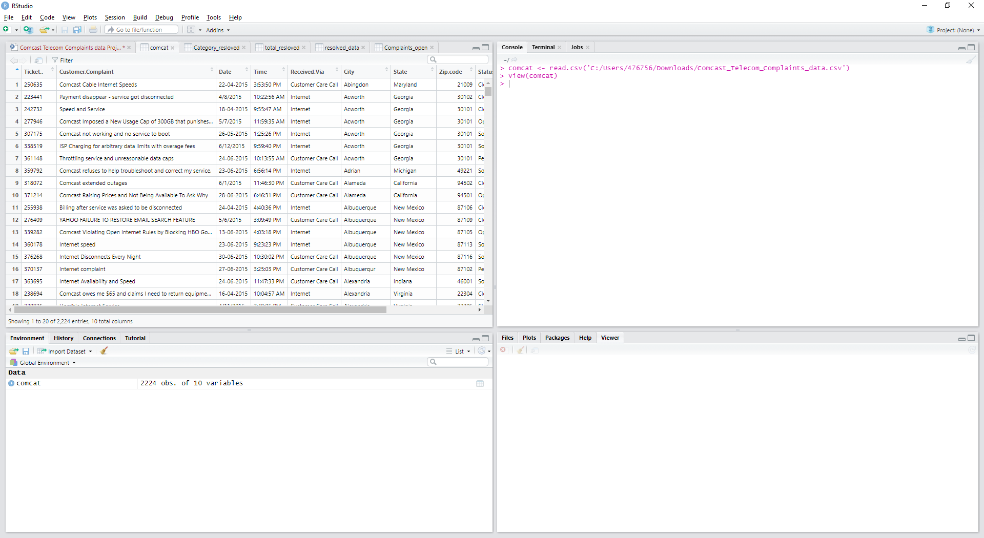

**##Renamed all the columns by removing '.'**

names(comcat) <- gsub(pattern = '\\.',replacement = '',x =names(comcat))

library(lubridate)

comcat$Date <- parse_date_time(comcat$Date, orders = "%d!-%m!-%y!")

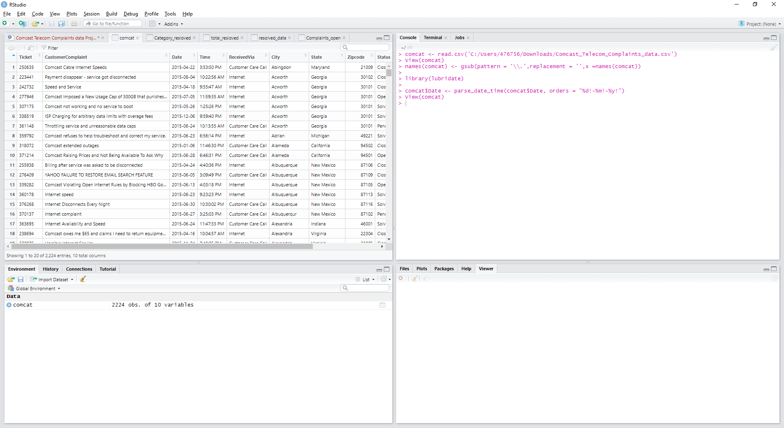

**##Provide the trend chart for the number of complaints at monthly ###**

comcat$Month <- strftime(comcat$Date,'%m')

monthly_count <- comcat %>% count(Month) %>% group_by(Month)

monthly_count<-monthly_count %>% rename(NoofTickets=n)

ggplot(data = monthly_count,aes(x=Month,y=NoofTickets,group=1))+geom_line(color="red")+geom_point()

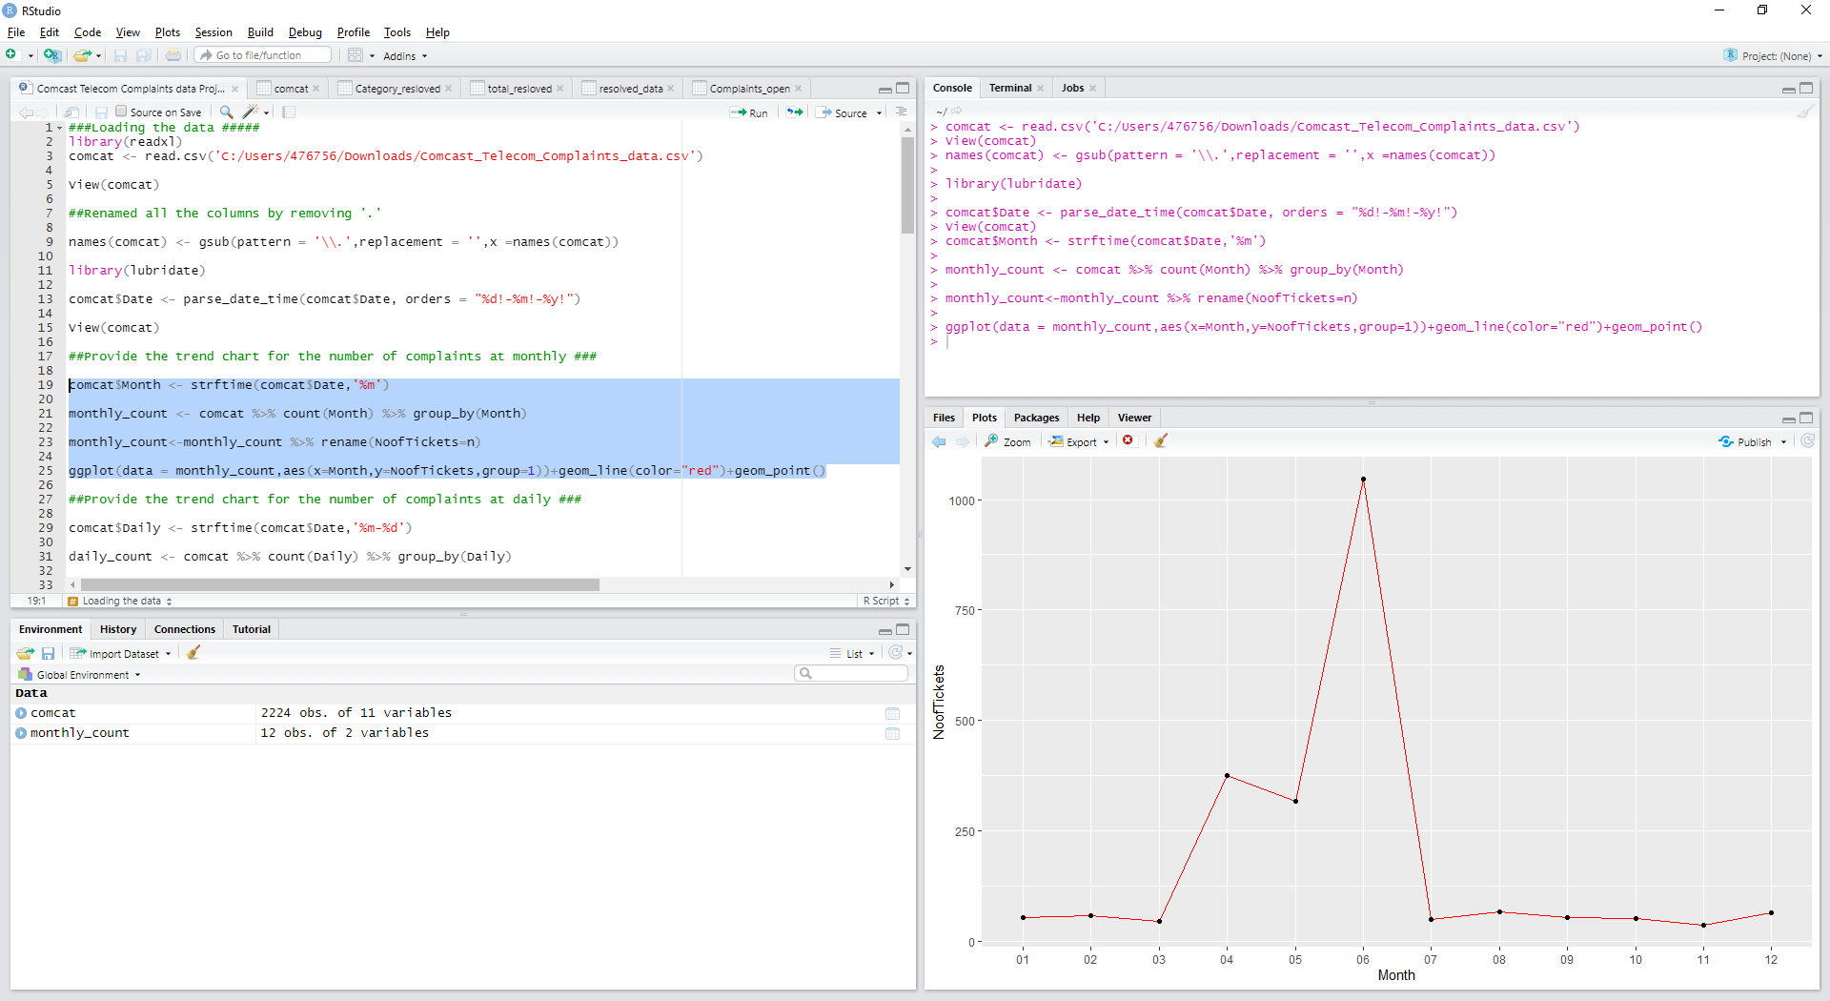

It is evident from the above graph that no of tickets is maximum in the month of June.

**##Provide the trend chart for the number of complaints at daily ###**

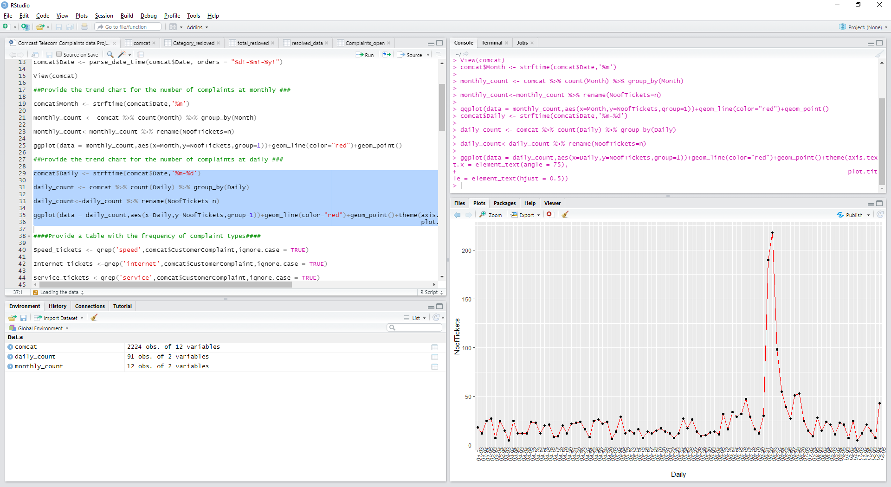

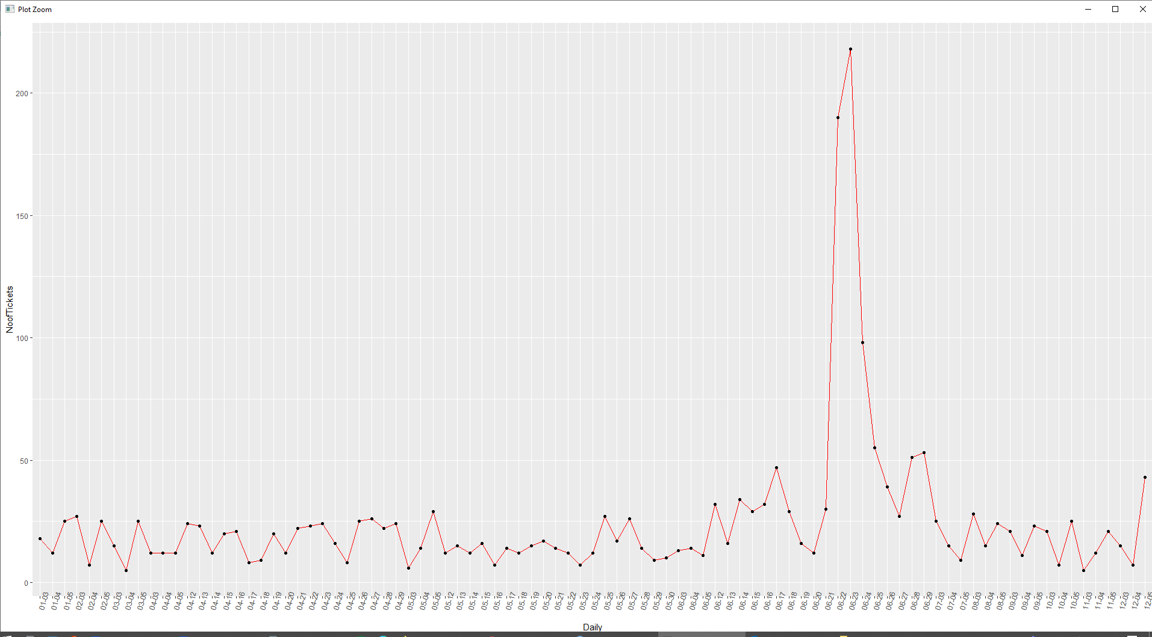

It is evident from the above graph that no of tickets is maximum on 24th June.

**####Provide a table with the frequency of complaint types####**

Categorized the different type of complaints based on the keyword from ‘CusomterComplaint’ column

Speed_tickets <- grep('speed',comcat$CustomerComplaint,ignore.case = TRUE)

Internet_tickets <-grep('internet',comcat$CustomerComplaint,ignore.case = TRUE)

Service_tickets <-grep('service',comcat$CustomerComplaint,ignore.case = TRUE)

Billing_tickets <-grep('billing',comcat$CustomerComplaint,ignore.case = TRUE)

Network_tickets <-grep('network',comcat$CustomerComplaint,ignore.case = TRUE)

comcat$ComplaintType[Speed_tickets] <- "Speed"

comcat$ComplaintType[Internet_tickets] <- "internet"

comcat$ComplaintType[Service_tickets] <- "service"

comcat$ComplaintType[Billing_tickets] <- "billing"

comcat$ComplaintType[Network_tickets] <- "network"

**####Frequency of complaint types.########**

comcat$ComplaintType[-c(Speed_tickets,Internet_tickets,Service_tickets,Billing_tickets,Network_tickets)] <- "Others"

table(comcat$ComplaintType)

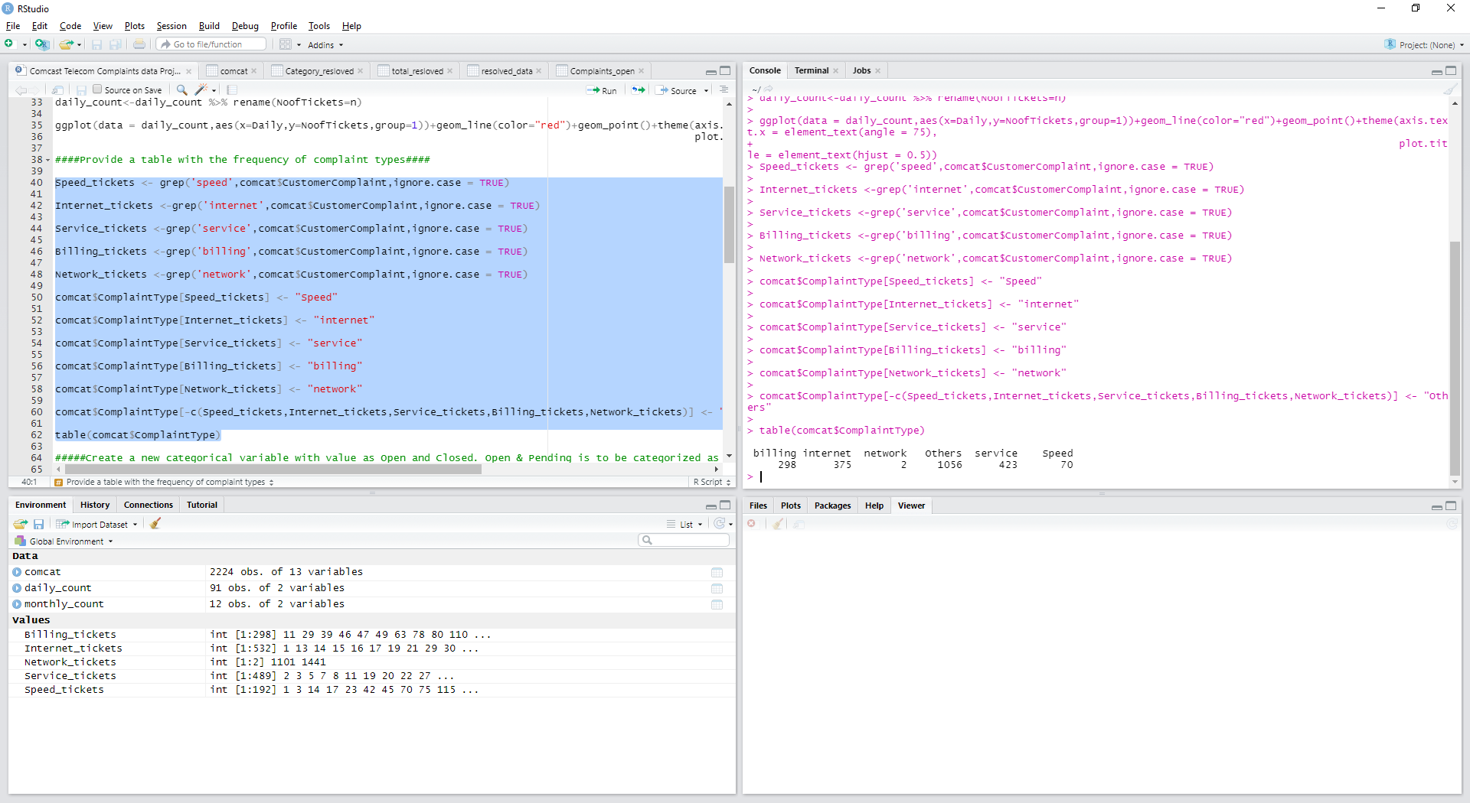

**#####Create a new categorical variable with value as Open and Closed. Open & Pending is to be categorized as Open and Closed & Solved is to be categorized as Closed.###**

Open_complaints <-(comcat$Status=="Open"|comcat$Status=="Pending")

Closed_complaints <-(comcat$Status=="Closed"|comcat$Status=="Solved")

comcat$ComplaintStatus[Open_complaints ] <- "Open"

comcat$ComplaintStatus[Closed_complaints] <- "Closed"

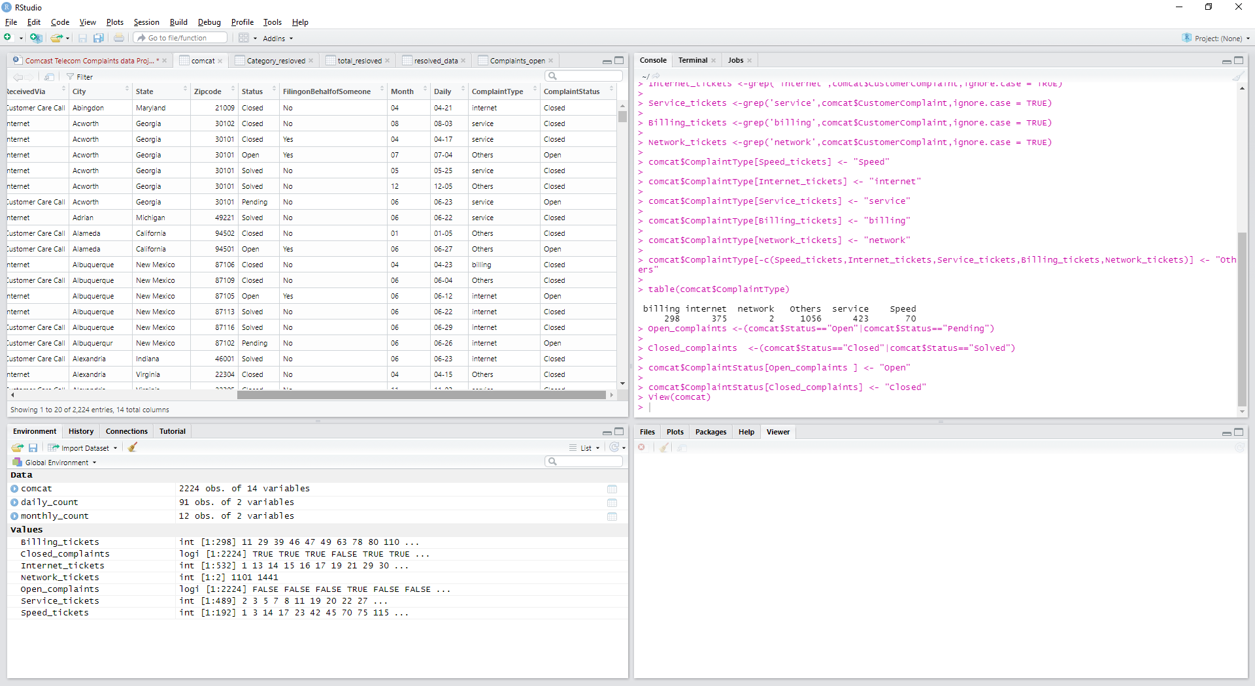

**#####- Provide state wise status of complaints in a stacked bar chart. Use the categorized variable from Q3. Provide insights on:**

**#########Which state has the maximum complaints###############**

comcat_statewise <- group_by(comcat,State,ComplaintStatus)

View(comcat_statewise)

stackedchart <- summarise(comcat_statewise,count=n())

View(stackedchart)

ggplot(stackedchart ,mapping = aes(State,count))+

geom_col(aes(fill = ComplaintStatus),width = 0.95)+

theme(axis.text.x = element_text(angle = 90),

axis.title.y = element_text(size = 15),

axis.title.x = element_text(size = 15),

title = element_text(size = 16,colour = "#005333FF"),

plot.title = element_text(hjust = 0.5))+

labs(title = "Ticket Status Stacked Bar Chart ",

x = "States",y = "No of Tickets",

fill= "Status")

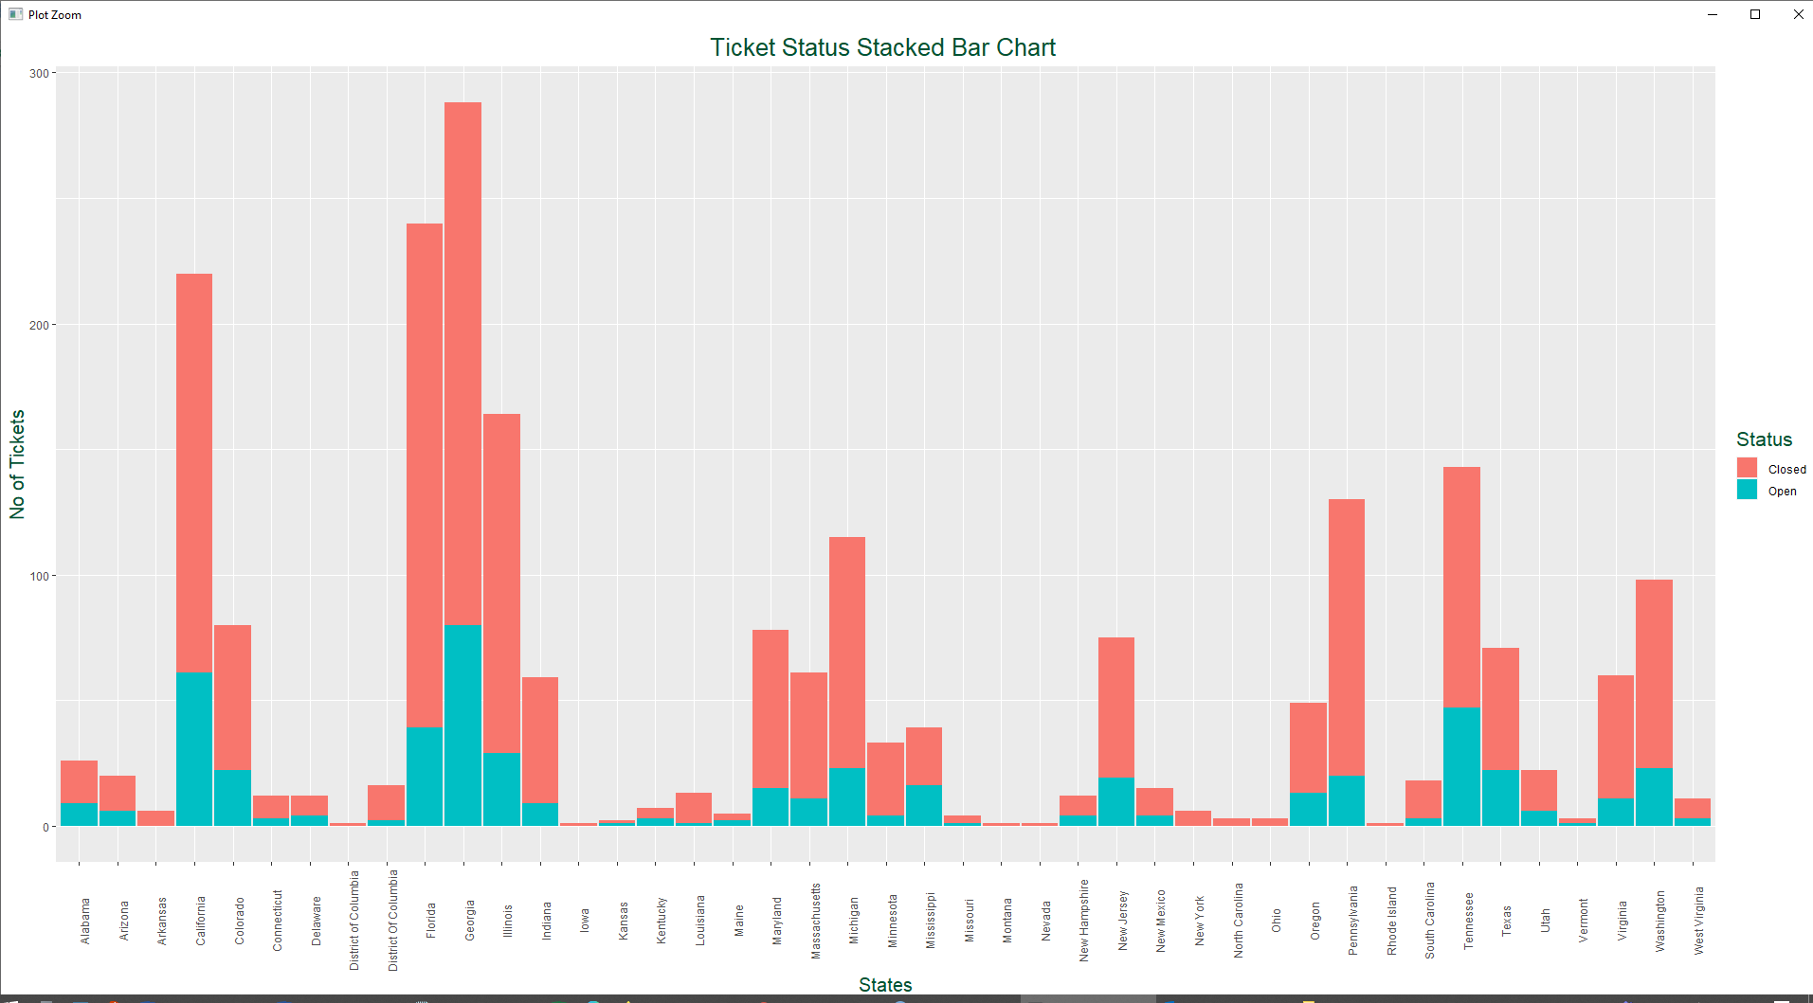

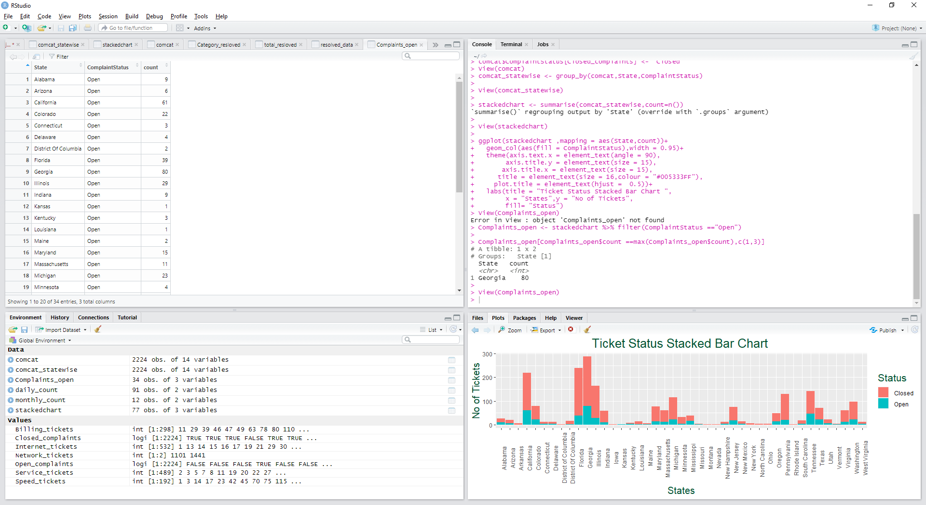

It is evident from the above graph that Georgia State have the most complaints. Florida is the second and California is the third in the list.

**#######Which state has the highest percentage of unresolved complaints #############**

Complaints_open <- stackedchart %>% filter(ComplaintStatus =="Open")

View(Complaints_open)

Complaints_open[Complaints_open$count ==max(Complaints_open$count),c(1,3)]

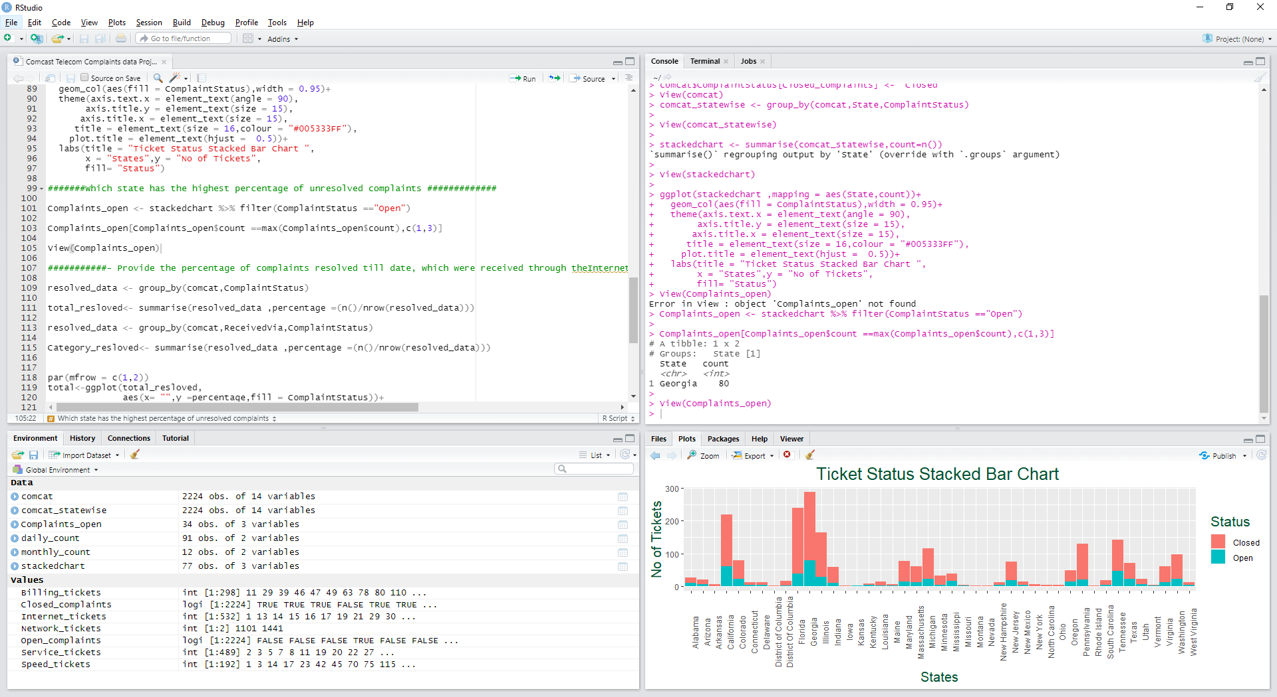

**###########- Provide the percentage of complaints resolved till date, which were received through theInternet and customer care calls.**

resolved_data <- group_by(comcat,ComplaintStatus)

total_resloved<- summarise(resolved_data ,percentage =(n()/nrow(resolved_data)))

resolved_data <- group_by(comcat,ReceivedVia,ComplaintStatus)

Category_resloved<- summarise(resolved_data ,percentage =(n()/nrow(resolved_data)))

par(mfrow = c(1,2))

total<-ggplot(total_resloved,

aes(x= "",y =percentage,fill = ComplaintStatus))+

geom_bar(stat = "identity",width = 1)+

coord_polar("y",start = 0)+

geom_text(aes(label = paste0(round(percentage*100),"%")),

position = position_stack(vjust = 0.5))+

labs(x = NULL,y = NULL,fill = NULL)+

theme_classic()+theme(axis.line = element_blank(),

axis.text = element_blank(),

axis.ticks = element_blank())

# Pie Chart for Category wise Ticket Status

category<-ggplot(Category_resloved,

aes(x= "",y =percentage,fill = ComplaintStatus))+

geom_bar(stat = "identity",width = 1)+

coord_polar("y",start = 0)+

geom_text(aes(label = paste0(ReceivedVia,"-",round(percentage*100),"%")),

position = position_stack(vjust = 0.5))+

labs(x = NULL,y = NULL,fill = NULL)+

theme_classic()+theme(axis.line = element_blank(),

axis.text = element_blank(),

axis.ticks = element_blank())

ggarrange(total,category,nrow = 1, ncol = 2)

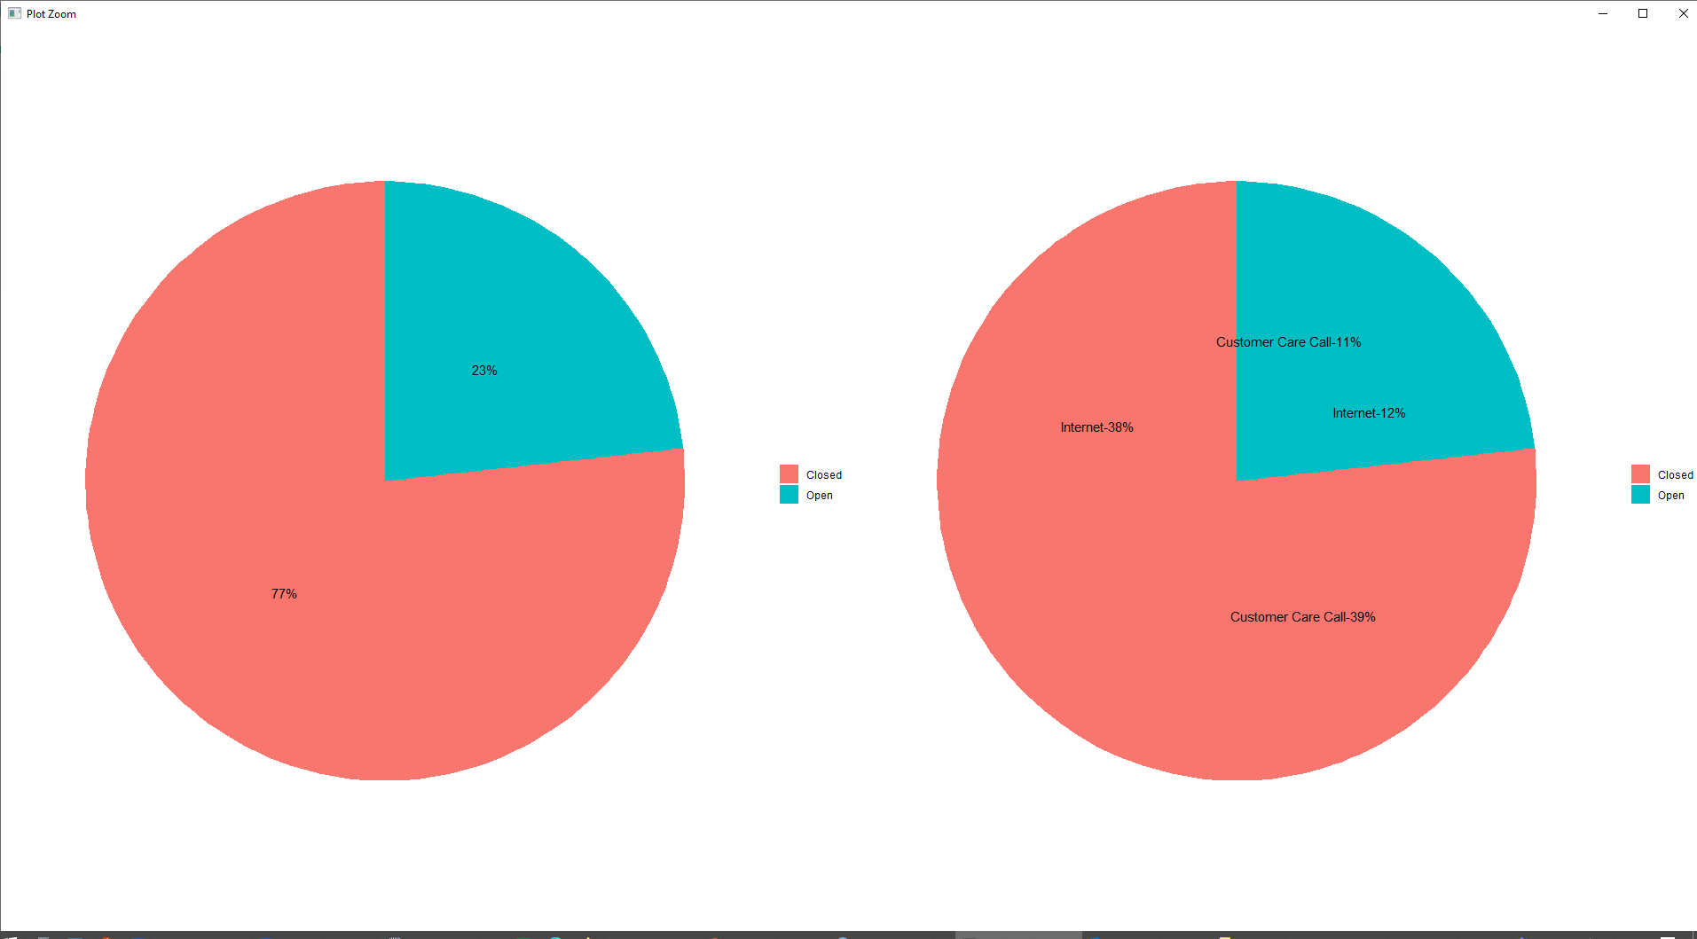

From the above graphs, it is evident that 23% of the complaints are open and 77% of the complaints have been closed

In the closed complaints, 39% where related to Customer care call and 38% where related to Internet

In the Open complaints, 11% where related to Customer care call and 12% where related to Internet

**Insights:**

* During the June month, Comcast received high amount of complaints in which most of the complaints are related to internet service issue
* Highest amount of complaints are received from the state Georgia.
* The highest unresolved complaints are related from the state Georgia
* The total amount of resolved complaints are 77% in which 38% are received the internet and 39% are from the customer care calls.